**DBMS LAB-07(06-02-2025)**

**Name-** Bhavya Shrivastava **Roll No-** 23052071 **Section-** CSE-15

**Q1. Create the following table and insert the values.**

**Job_History**

|  |  |  |  |  |
| --- | --- | --- | --- | --- |
| **Emp_id** | **Start_Date** | **End_Date** | **Job_Type** | **D_Name** |
| **1** | **4-Jan-1998** | **30-Jun-2001** | **Engineer** | **Production** |
| **2** | **9-Feb-1998** | **28-Feb-2002** | **Salesman** | **Sales** |
| **1** | **1-Jul-2001** | **31-Dec-2010** | **Manager** | **R&D** |
| **4** | **27-Dec-2001** | **19-Sep-2016** | **Sales_Executive** | **Marketing** |
| **2** | **1-Mar-2002** | **30-Mar-2015** | **Sales_Executive** | **Marketing** |
| **2** | **1-Apr-2016** | **15-Dec-2017** | **Manager** | **Sales** |
| **4** | **20-Sep-2016** | **16-Dec-2017** | **Asst.Manager** | **Sales** |
| **6** | **16-Jul-2000** | **30-Nov-2006** | **Clerk** | **Accounts** |
| **5** | **20-Mar-2002** | **12-Aug-2011** | **Engineer** | **R&D** |
| **1** | **1-Jan-2011** | **31-Jan-2012** | **Engineer** | **Production** |

**Using the above Job_History table and the Employee table (of assignment 2) write SQL statements for the following queries.**

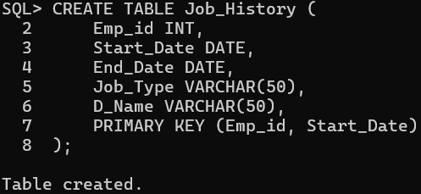

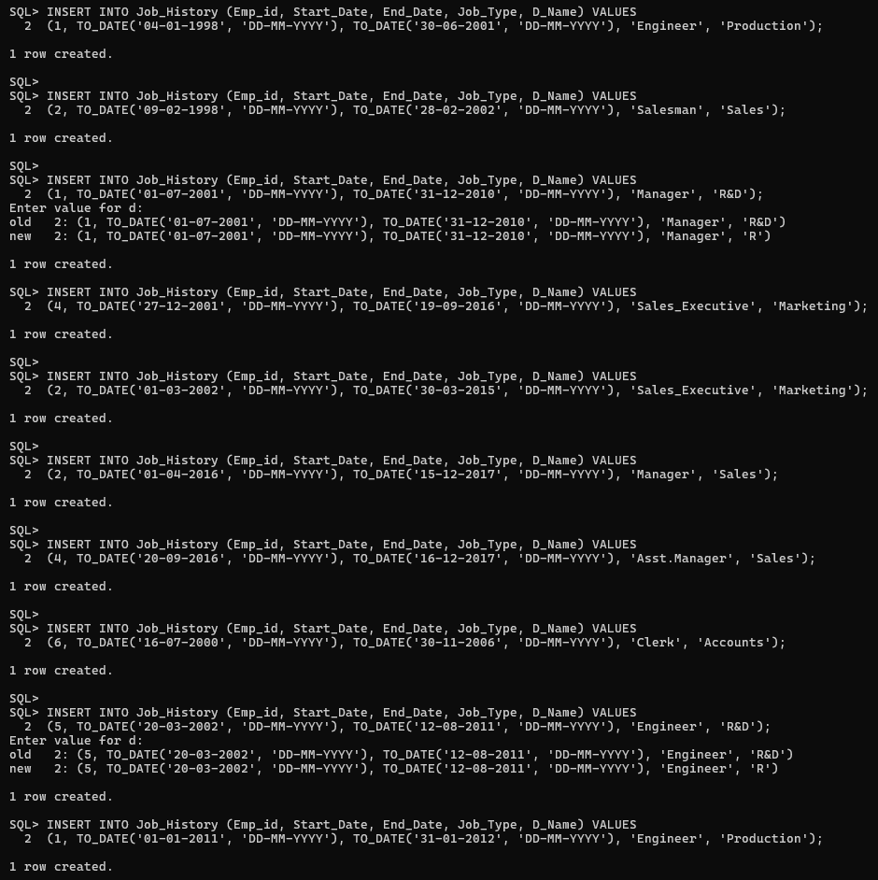

**Q2. Display the current and previous (if any) job_types of all employees. (use union/union all)**

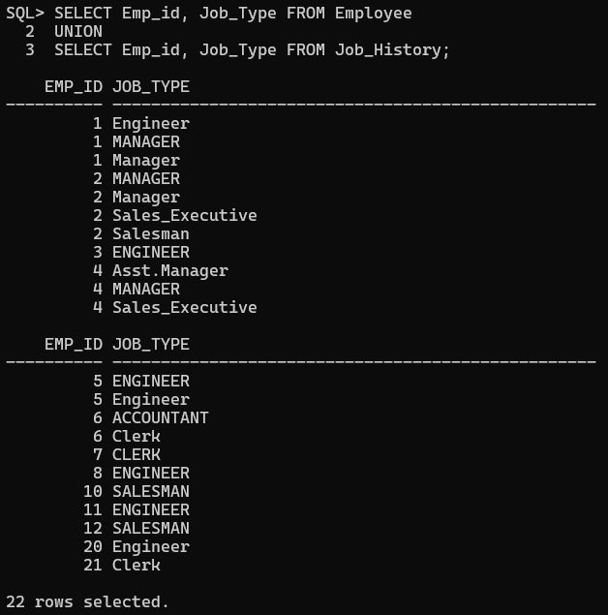

**Q3. Display the emp_id, d_name, and job_types current and previous (if any) of all employees.(use union/union all)**

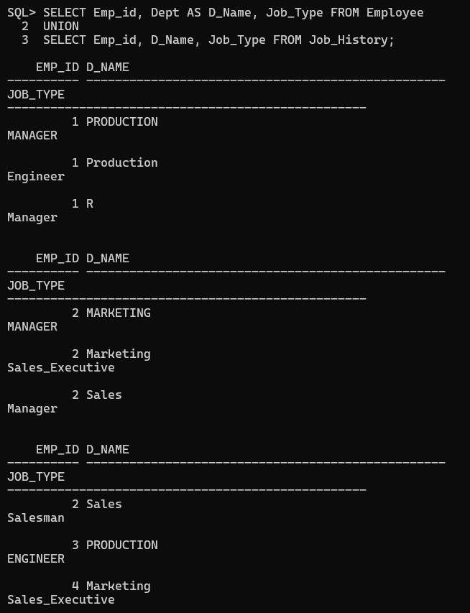

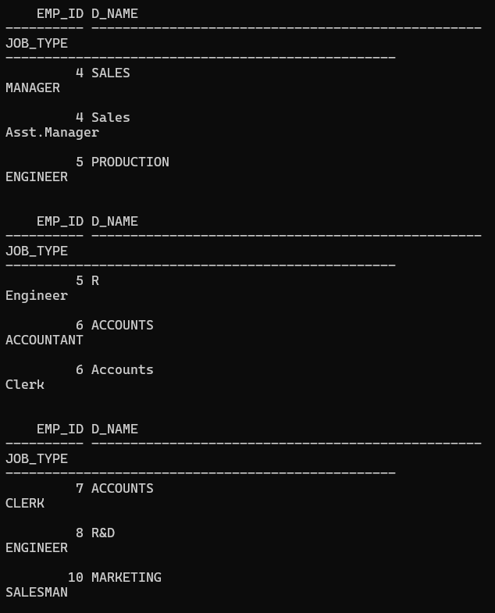

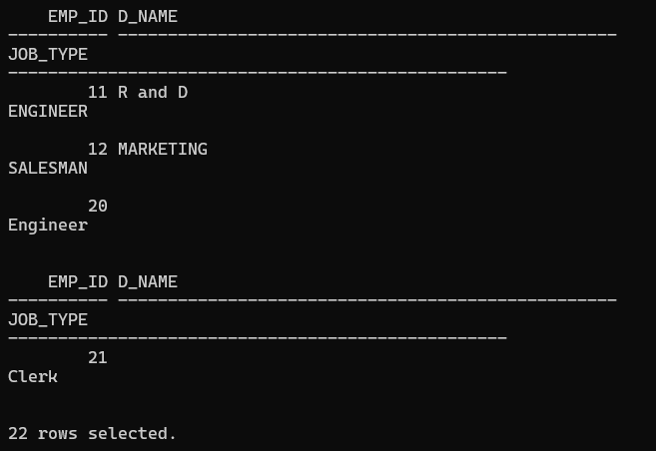

**Q4. Display the emp_id and the job_type of employees who currently have a job title that they held previously.(use intersect)**

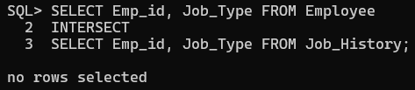

**Q5. Find the employees who have not changed their job for once.(use minus)**

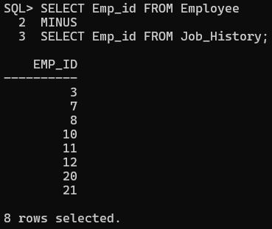

**Q6. Find the employees who earn more than Chitra. (use single-row subquery)**

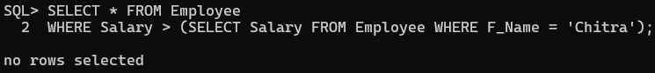

**Q7. Find the employees details who have the same job_type as of emp_id 7. (use single-row subquery)**

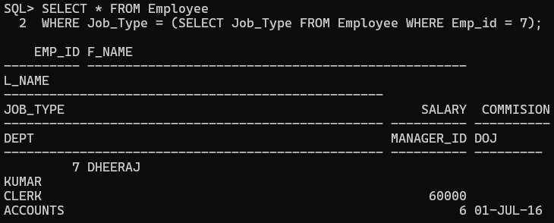

**Q8.Display the employee names whose job is the same as employee 3 and earn more than employee 7. (use single-row subquery) 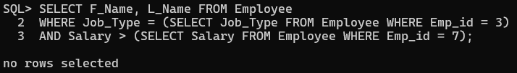**

**Q9. Display the employees earning less than the average salary. (use single-row subquery)** 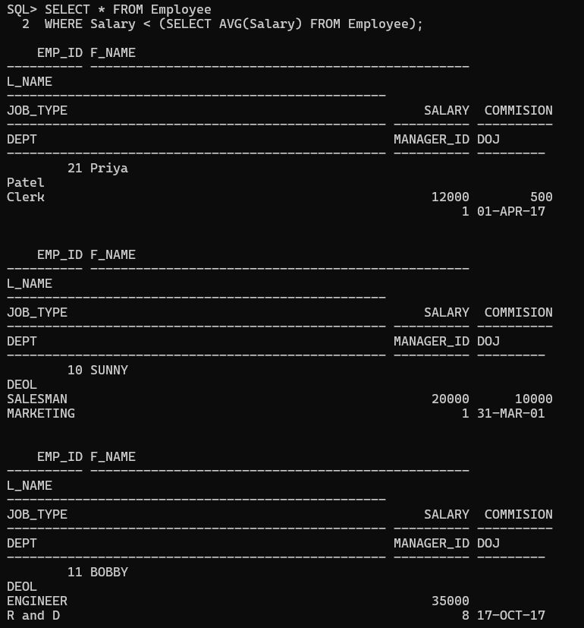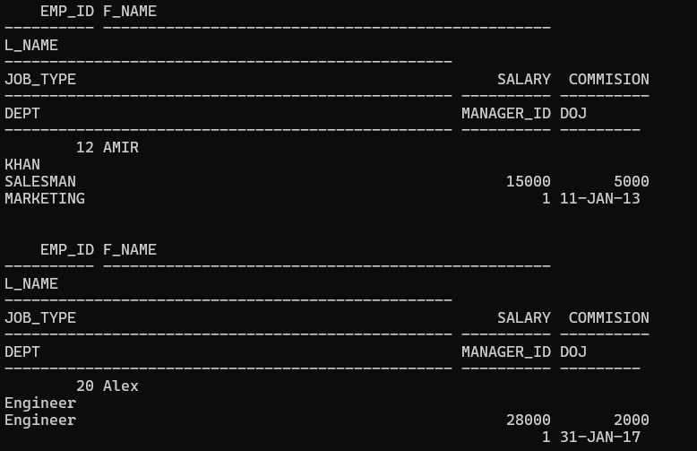

**Q10. Find the job_type with the lowest average salary. (use single-rowsubquery)**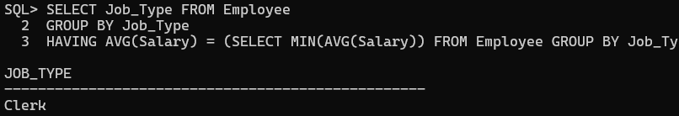

**Q11. Display all the department names whose minimum salary is greater than the minimum salary of the Sales department.**

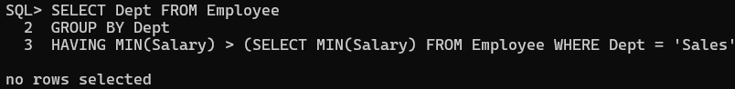

**Q12. Select the employee names, department and salary who are the lowest earners of their corresponding department (use multi-row subquery). 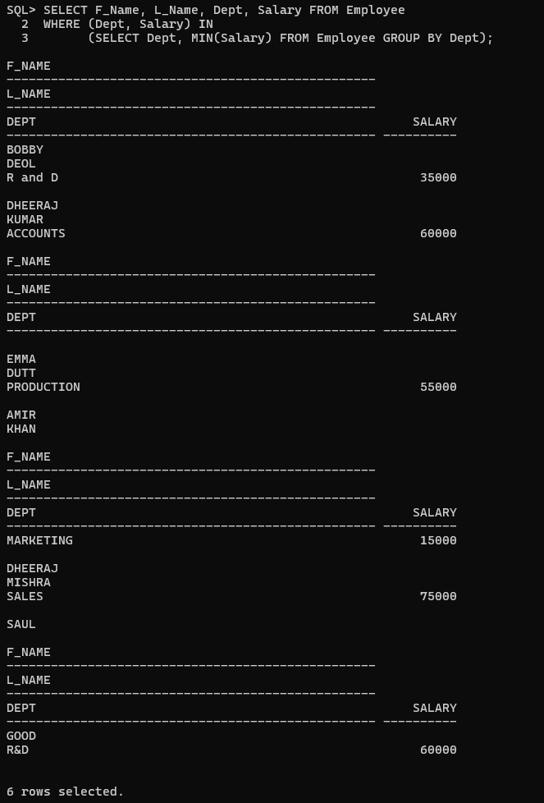**

**Q13. Find the highest earners of each job_type.(use multi-row subquery). 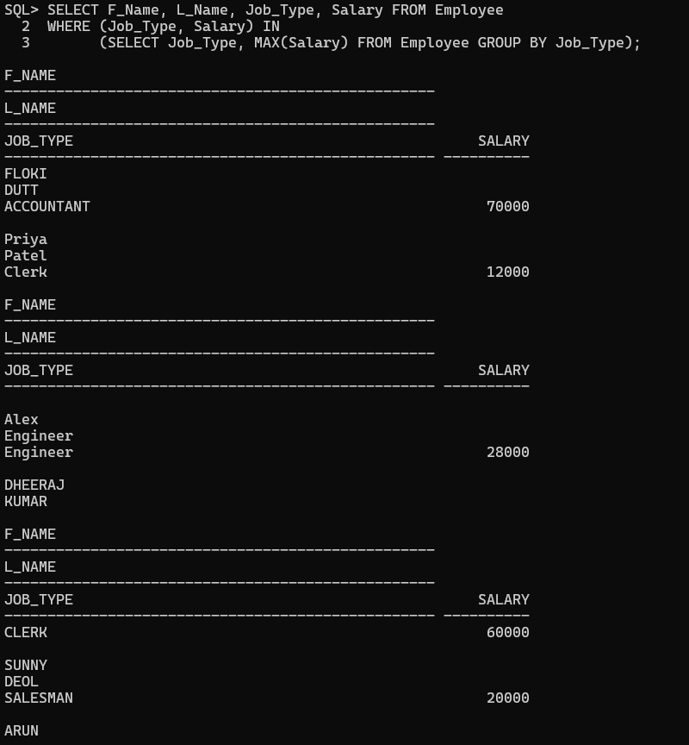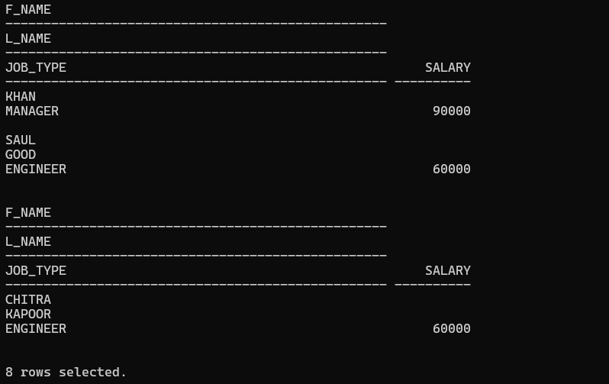**

**Q14. Display the employees who are not engineers and earn less than any engineer.(use multi-row subquery). 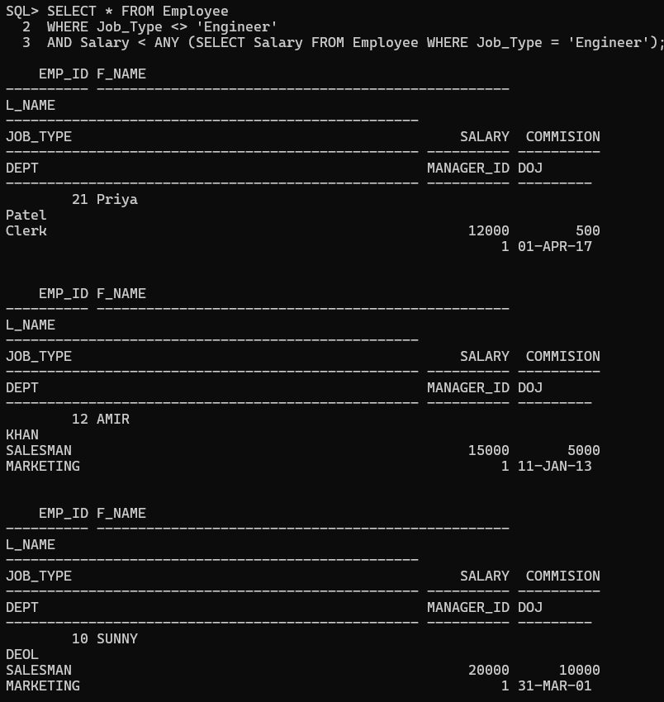**

**Q15. Display the employees who are not clerks but earn more than all clerks.(use multi-row subquery).**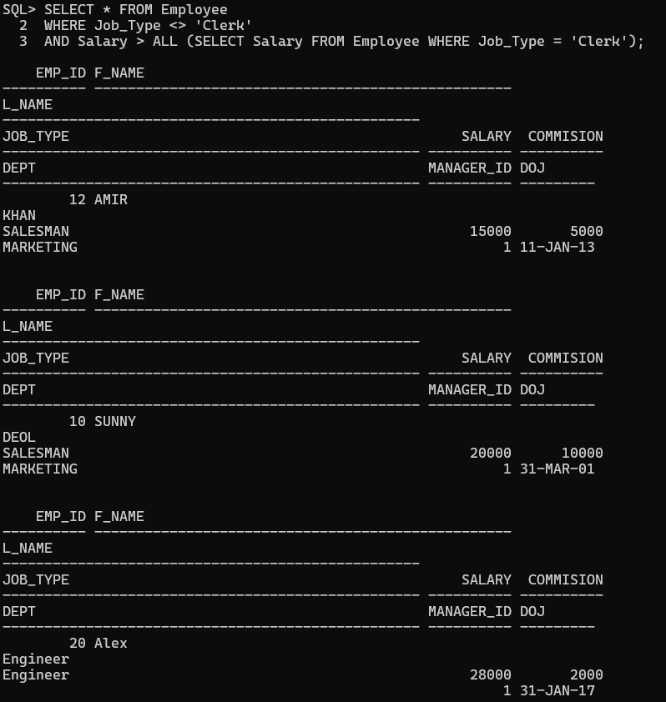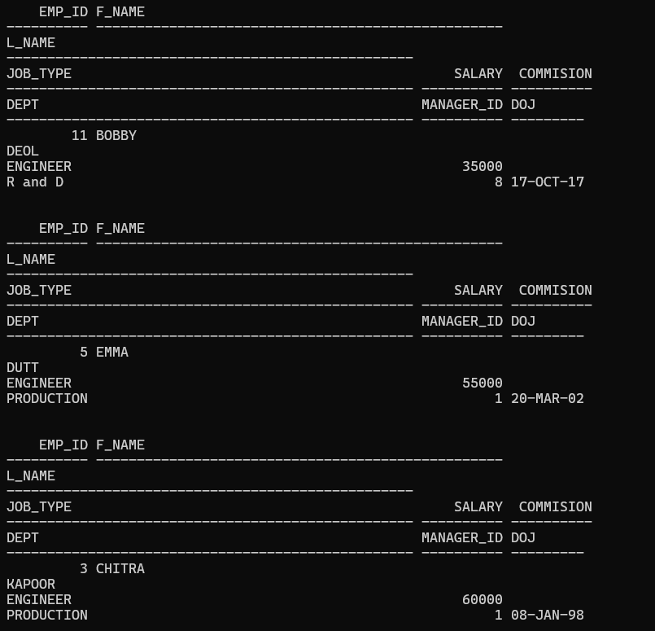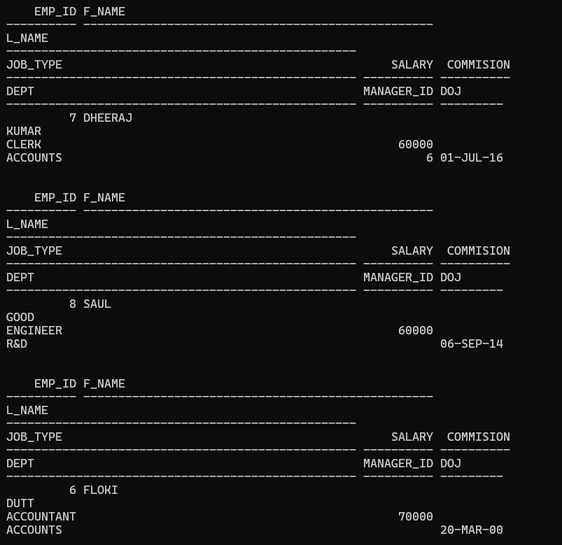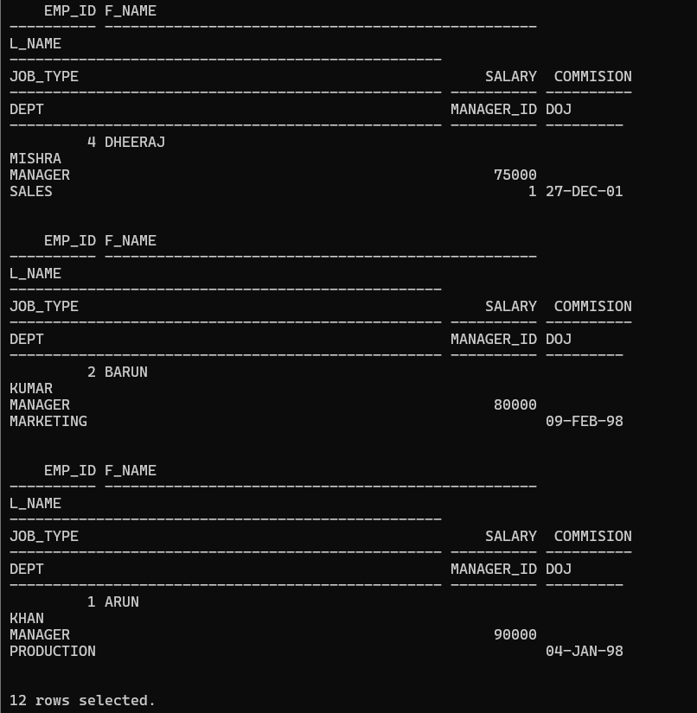

**Q16. Display the top 5 highest earning employees** 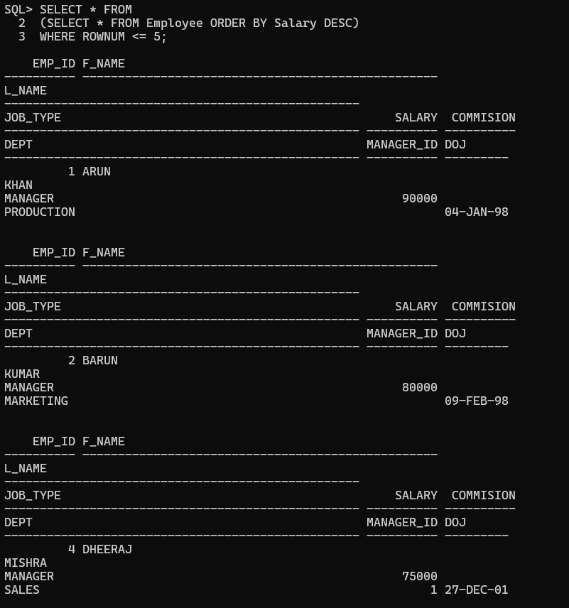

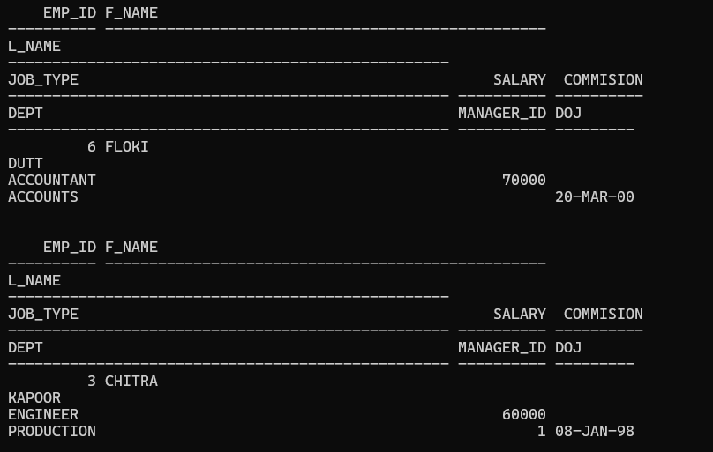

**Q17. Display the name and department of the top 2 highest paid managers.**

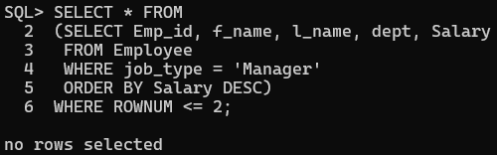

**Q18. Update the salary of the employees working as managers to the average salary of all the employees.**

